**Topics: Descriptive Statistics and Probability**

1. **Look at the data given below. Plot the data, find the outliers and find out $μ, σ, σ^{2}$**

|  |  |
| --- | --- |
| **Name of company** | **Measure X** |
| Allied Signal | 24.23% |
| Bankers Trust | 25.53% |
| General Mills | 25.41% |
| ITT Industries | 24.14% |
| J.P.Morgan & Co. | 29.62% |
| Lehman Brothers | 28.25% |
| Marriott | 25.81% |
| MCI | 24.39% |
| Merrill Lynch | 40.26% |
| Microsoft | 32.95% |
| Morgan Stanley | 91.36% |
| Sun Microsystems | 25.99% |
| Travelers | 39.42% |
| US Airways | 26.71% |
| Warner-Lambert | 35.00% |

**Ans:**

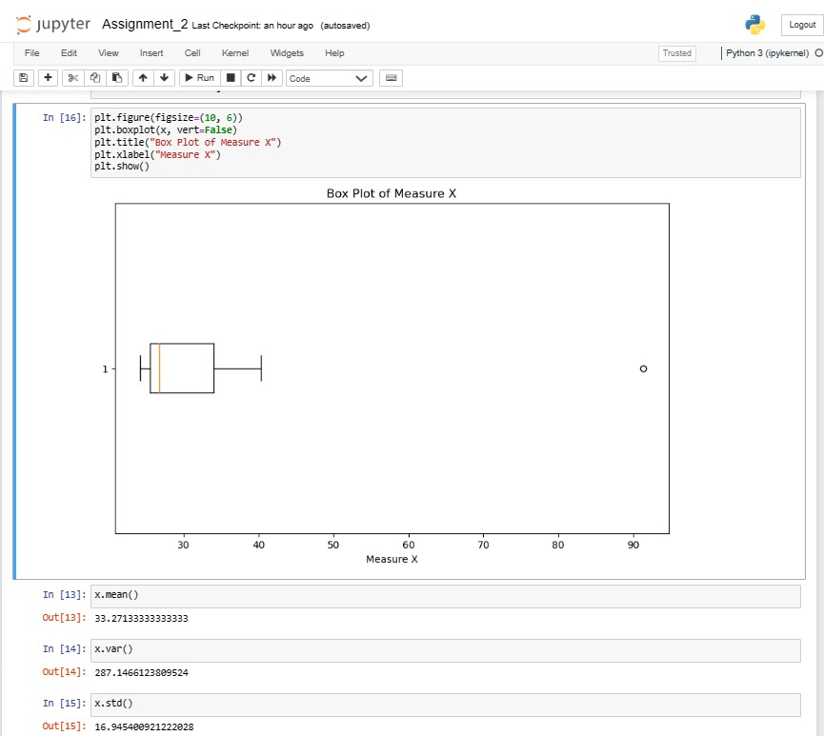



**Answer the following three questions based on the box-plot above.**

1. **What is inter-quartile range of this dataset? (please approximate the numbers) In one line, explain what this value implies.**

**Ans:** IQR is the range between upper quartile (Q3) and lower quartile (Q1)

IQR= Q3-Q1= 12-5 = 7

Second quartile range is the median value.

1. **What can we say about the skewness of this dataset?**

**Ans:** Right skewed = positive

1. **If it was found that the data point with the value 25 is actually 2.5, how would the new box-plot be affected?**

**Ans:** The dataset will be right skewed but the median of the boxplot is changes a

little bit.



**Answer the following three questions based on the histogram above.**

1. **Where would the mode of this dataset lie?**

**Ans:** The mode of this data set lies between 5 to 10.

1. **Comment on the skewness of the dataset.**

**Ans:** Right skewed = positive

1. **Suppose that the above histogram and the box-plot in question 2 are plotted for the same dataset. Explain how these graphs complement each other in providing information about any dataset.**

**Ans:** There is an outlier of the value 25 and both the plot has positive skewness

1. **AT&T was running commercials in 1990 aimed at luring back customers who had switched to one of the other long-distance phone service providers. One such commercial shows a businessman trying to reach Phoenix and mistakenly getting Fiji, where a half-naked native on a beach responds incomprehensibly in Polynesian. When asked about this advertisement, AT&T admitted that the portrayed incident did not actually take place but added that this was an enactment of something that “could happen.” Suppose that one in 200 long-distance telephone calls is misdirected. What is the probability that at least one in five attempted telephone calls reaches the wrong number? (Assume independence of attempts.)**

**Ans:** X = probability of 1 call misdirected out of 200

Probability of call misdirected = 1/200

P(X)= 1/200

Probability of call not misdirected

1-P(X)= 1-1/200= 199/200= 0.967

As every event is independent of other event the probability will be

1- (0.967) ^5

0.02475 = 2% chance.

1. **Returns on a certain business venture, to the nearest $1,000, are known to follow the following probability distribution**

|  |  |
| --- | --- |
| **x** | **P(x)** |
| -2,000 | 0.1 |
| -1,000 | 0.1 |
| 0 | 0.2 |
| 1000 | 0.2 |
| 2000 | 0.3 |
| 3000 | 0.1 |

1. **What is the most likely monetary outcome of the business venture?**

**Ans:** The most likely monetary outcome of the business venture $2000. As for the

$2000 the probability is 0.3 which is maximum than compared to others.

1. **Is the venture likely to be successful? Explain**

**Ans:** Yes, the probability that the venture will make more than 0 or a

Profit p(x>0) + p(x>1000) + p(x>2000) + p(x=3000) =

0.2+0.2+0.3+0.1 = 0.8

This states that there are 80% chances for this venture to be making

a profit.

1. **What is the long-term average earning of business ventures of this kind? Explain**

**Ans:** The long-term average is expected value = sum(x*p(x)) = $800

which means on an average the returns will be 800$

1. **What is the good measure of the risk involved in a venture of this kind? Compute this measure**

**Ans:** A good measure to evaluate the risk would be variance and standard deviation

of the variable x

Var = 3500000

Sd = 1870.83

The large value of standard deviation of $1870 is considered along with the average returns of $800 indicates that this venture is highly risky